Quantified Student

LTI research and reflection

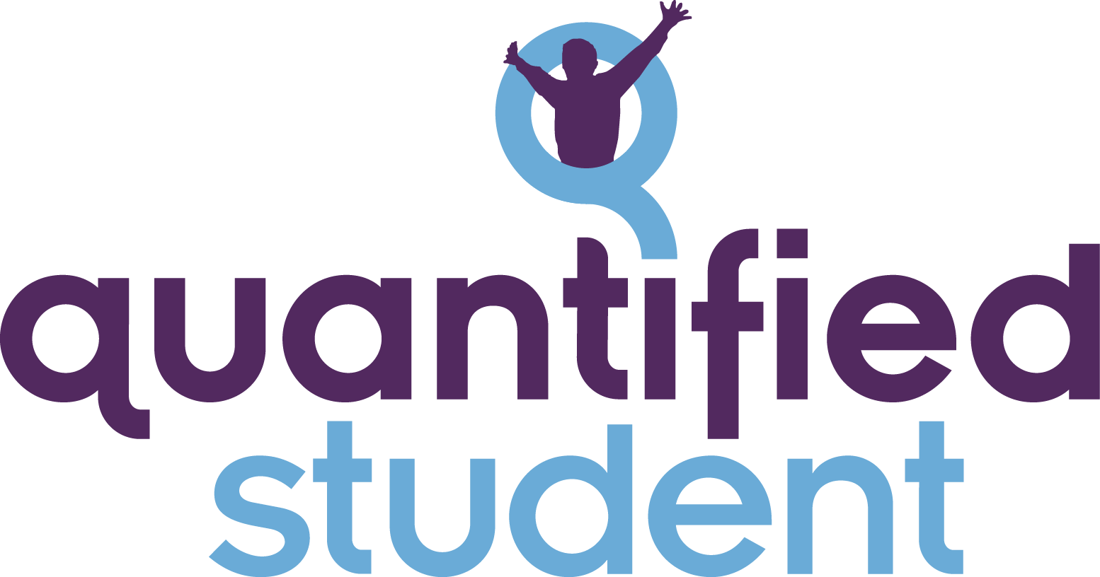

Neal Geilen

# Content

**Content** **1**

**Version History** **2**

**Introduction** **3**

**LTI** **4**

**Research and prototyping** **5**

Research 5

Prototyping 5

**Conclusion** **6**

# 

# Version History

| Version | Date | Author | Comment |
| --- | --- | --- | --- |
| 0.1 | 07-06–2022 | Neal | Start document |
| 0.2 | 21/06/2022 | Neal | Changes after feedback |
|  |  |  |  |

# 

# Introduction

Quantified student (QS) wants to help students with their performance, QS wants to show relevant information about the student in a dashboard that would be placed inside Canvas. Canvas is an LMS (Learning management system) and it can integrate other applications. This document will outline how this will work and what is needed to have this work.

# LTI

The integration technique that we will use to add an application to Canvas is an LTI “Learning Tools Interoperability”. LTI is an open-source standard for tools that can integrate into LMS systems. The standard is regulated by [1edtech](https://www.1edtech.org/).

For our purposes, we wanted to add LTI support to our application so that we have seamless integration with Canvas.

# 

# Research and prototyping

## Research

For researching this the first source of information was the [Canvas API](https://canvas.instructure.com/doc/api/) documentation. In the documentation, it is outlined what is needed to have the LTI integrated with Canvas. LTI is a standard but that does not mean platforms cant add to the platform.

For a better and clear picture of what an LTI entails it is best to read the documentation of [1edtech](https://www.imsglobal.org/activity/learning-tools-interoperability).

The main takeaway from all the documentation is that an LTI is also known as a “Tool” and this tool is going to be integrated inside a “platform”. A platform is also called an LMS like Canvas.

## Prototyping

After reading the documentation it is time to figure out how all the pieces fit together. The thing with prototyping is that we don't have a platform for testing and developing a Tool. But there are applications online that advertise that they can help with the development of a tool. these applications function then as a platform.

examples of this are the following.

* <https://saltire.lti.app/tool>
* <https://lti-ri.imsglobal.org/>

These online applications can help with development.

For building the tool itself I came across a NodeJs package that helps with building a Tool. This package is called [Ltijs](https://cvmcosta.me/ltijs/#/). This package has also demo applications that show the working of the package. Therefore I choose to fork the demo application. [The server](https://github.com/quantifiedstudent/ltijs-demo-server) and [the client](https://github.com/quantifiedstudent/ltijs-demo-client) and add Docker support for easier development. With Docker added I deployed the demo application on a VPS that already was created for other QS prototypes.

With the demo tool publicly accessible and the development platforms are known it was time for combining the two.

At this point in the process, the confusing part of LTIs started. The beforementioned development platforms lack clear documentation and clear purpose. Yes, they are made for creating tools. But the settings that you need to give to have a tool added are not labelled and the settings that are labelled have ambiguous names like “Login URL”. There are no clear details on what this page needs to have or what the platform is going to do whit it.

# Conclusion

After working with these development platforms and trying out this demo application for some weeks it became clear that this is something that is now not feasible to have integrated into the application. we have chosen for now to add the QS dashboard inside Canvas with the help of another LTI called ”Redirect Tool”.This LTI lets the use integrate an Iframe into the canvas course. We could use this Iffame to integrate a QS dashboard. This is for now the best way to have a working prototype at the end of the semester.

Besides this, I want to add that the LTI development is indeed an issue and needs a lot of work. For the next iteration of QS, I want to emphasise that this is something for two people or more to work on. You cant get this working just alone. There are too many moving parts to get this working.